Data Binding, Lifecycle Hooks & Component Communication
Task 1: All Four Binding Types
Goal: Practise interpolation, property binding, event binding, and two-way binding in one component.
App.ts:
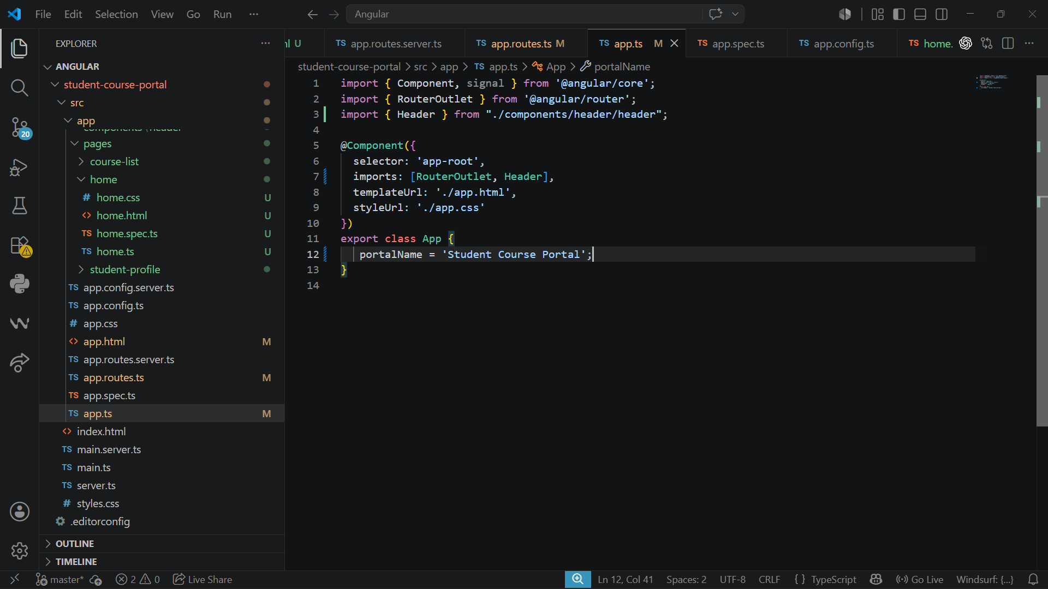
Home.html:
Including Enroll Now Button and Search Option for selecting
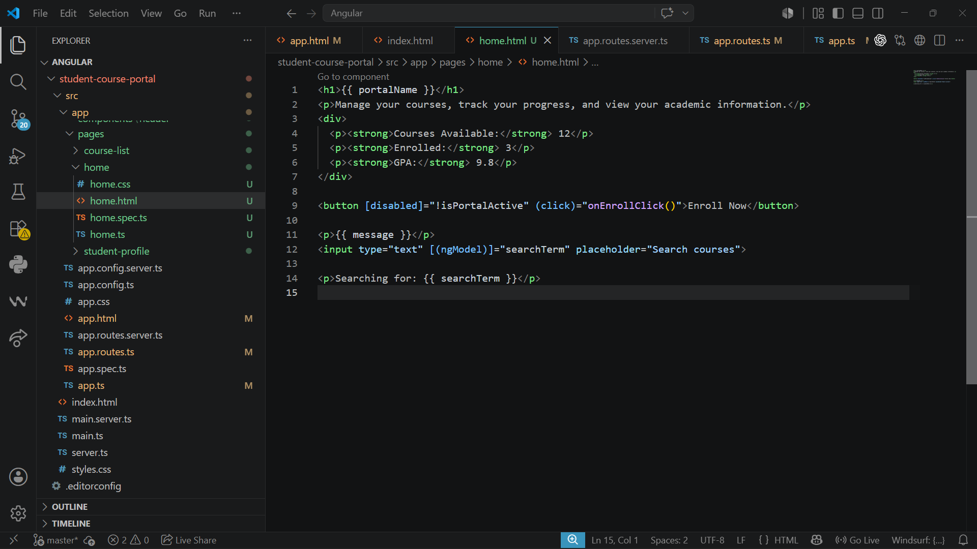

home.ts:
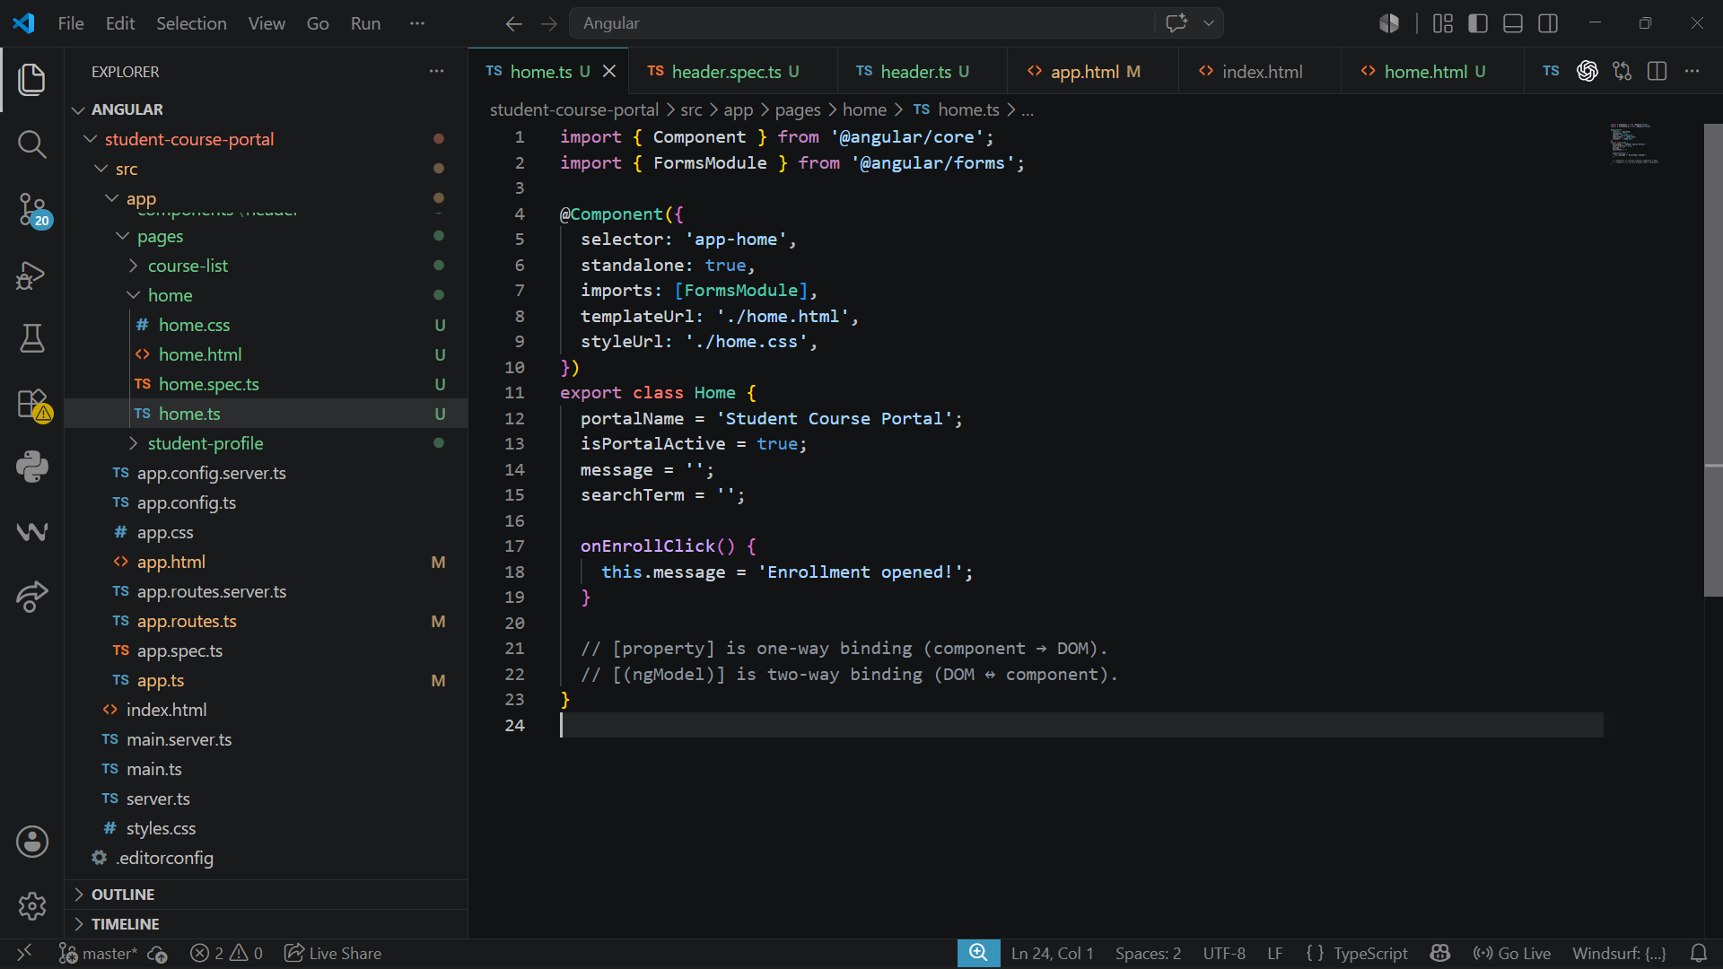
Output:

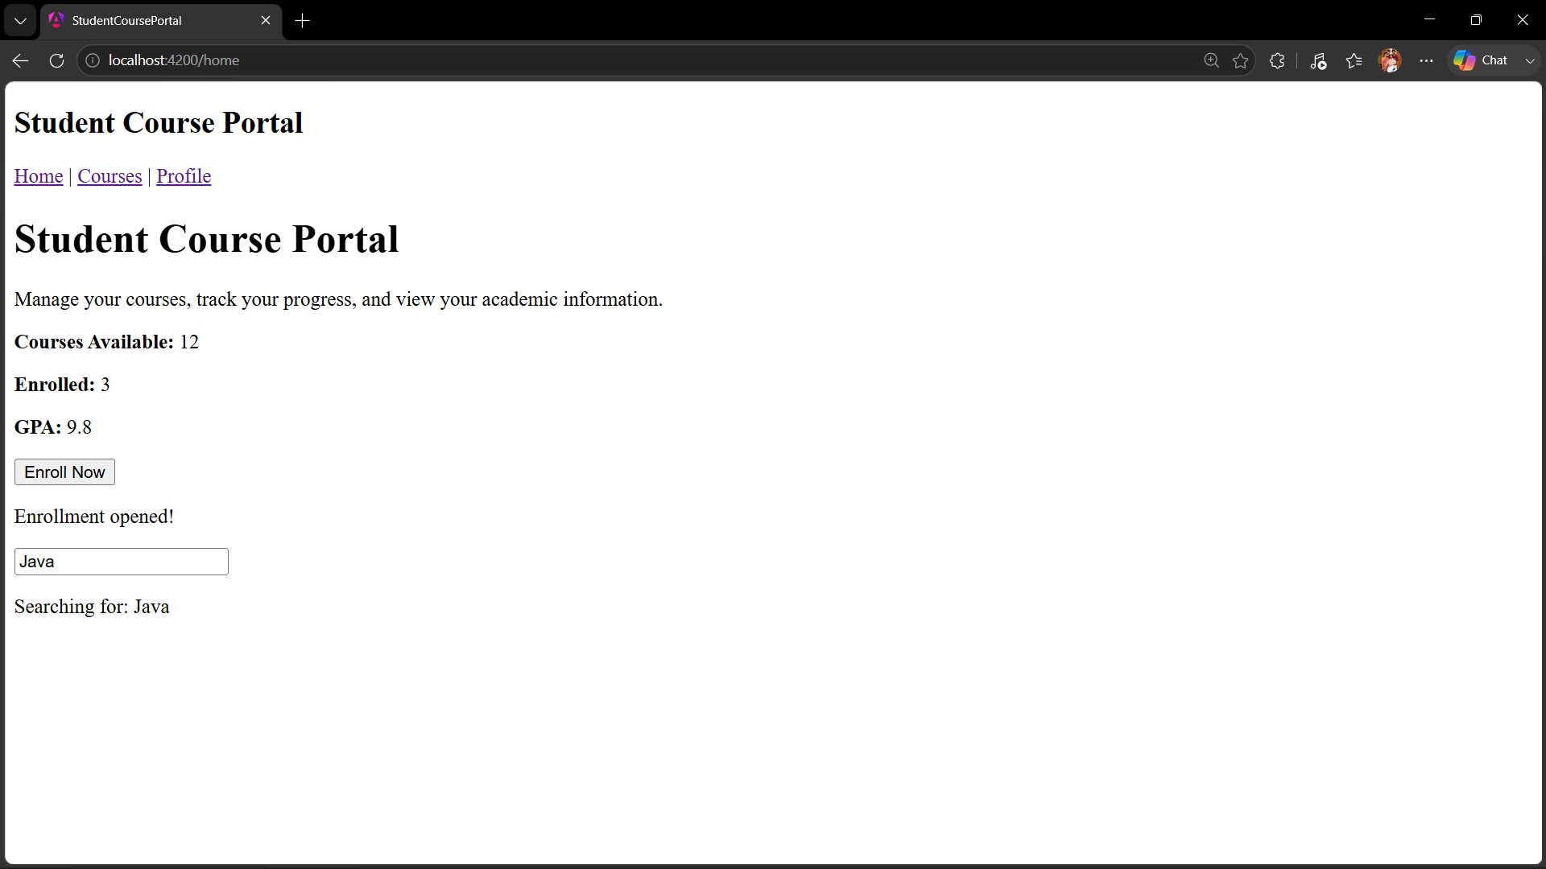

Task 2: Lifecycle Hooks
Goal: Implement the three most important lifecycle hooks and observe when they fire.
Home.ts:
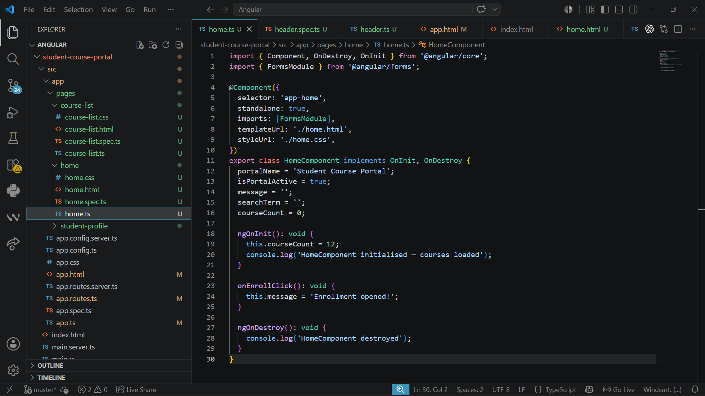
CourseCardComponent:
Creation and Edited Code
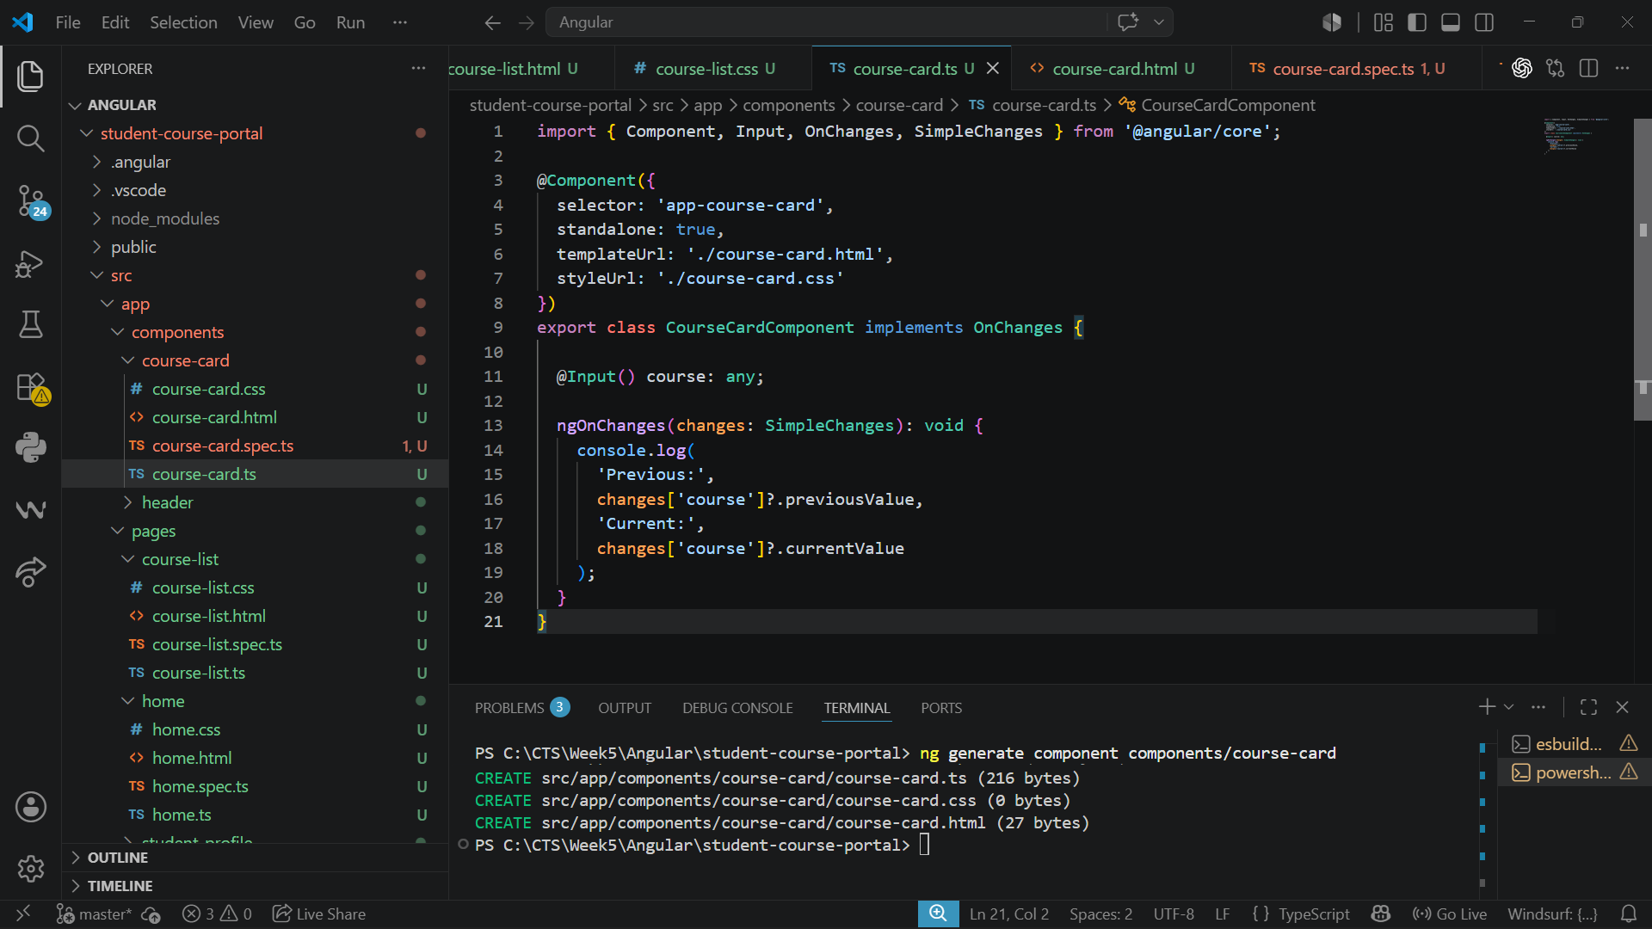

Course-list.ts:
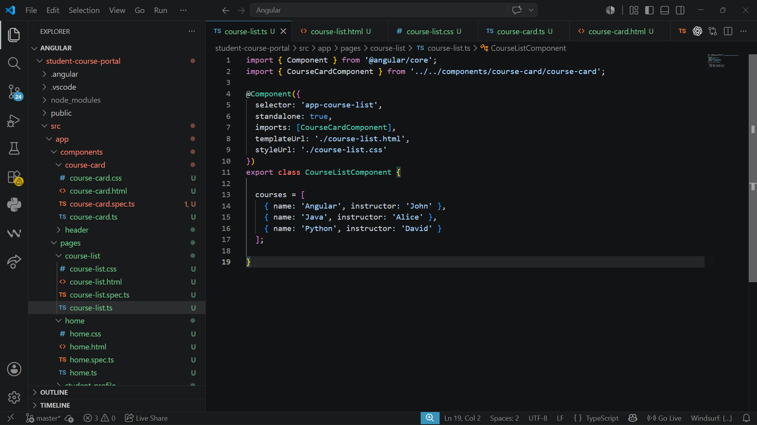
Output:
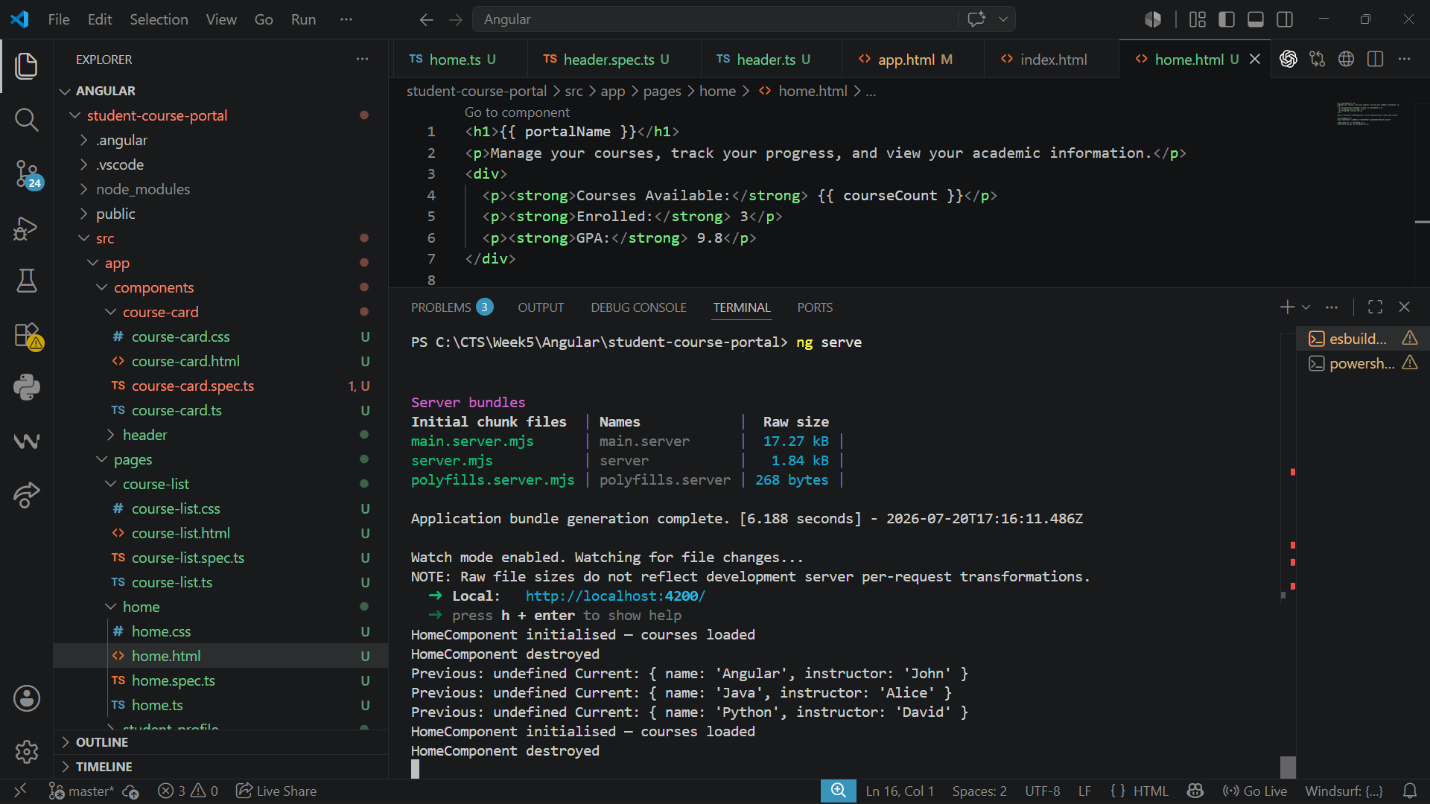
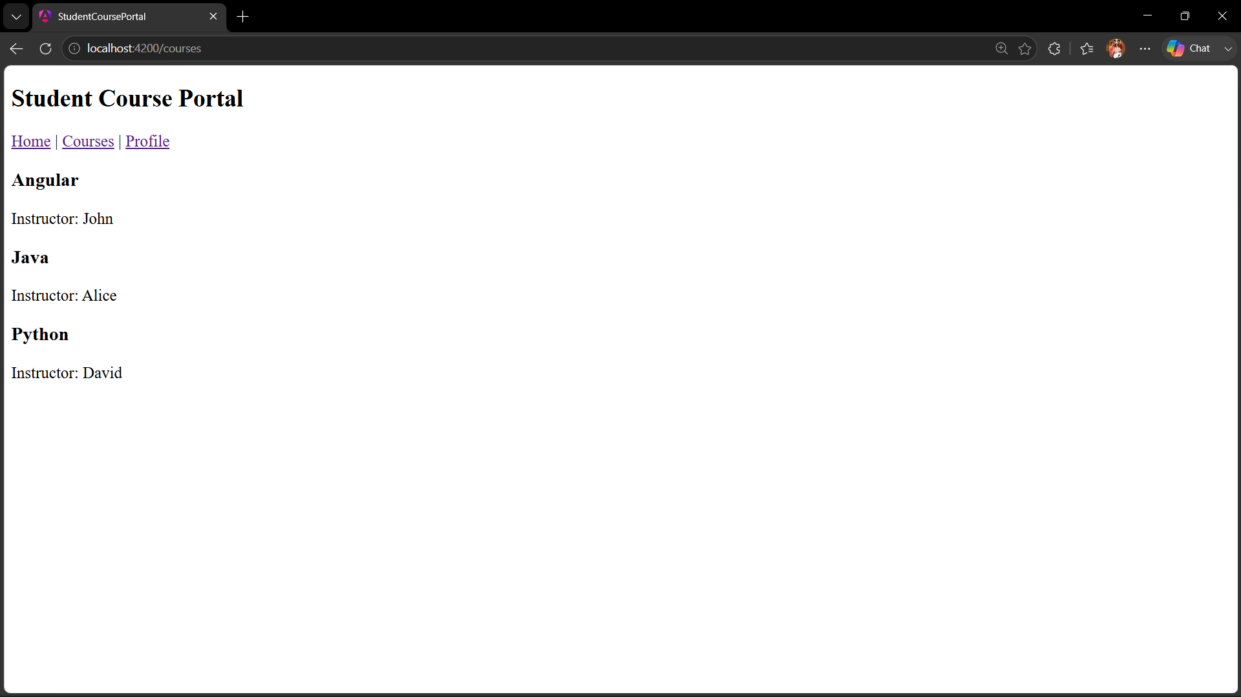
Task 3: @Input and @Output — Parent-Child Communication
Goal: Pass data down with @Input and emit events up with @Output
Course-card.ts:
Adding @Input() and @Output()
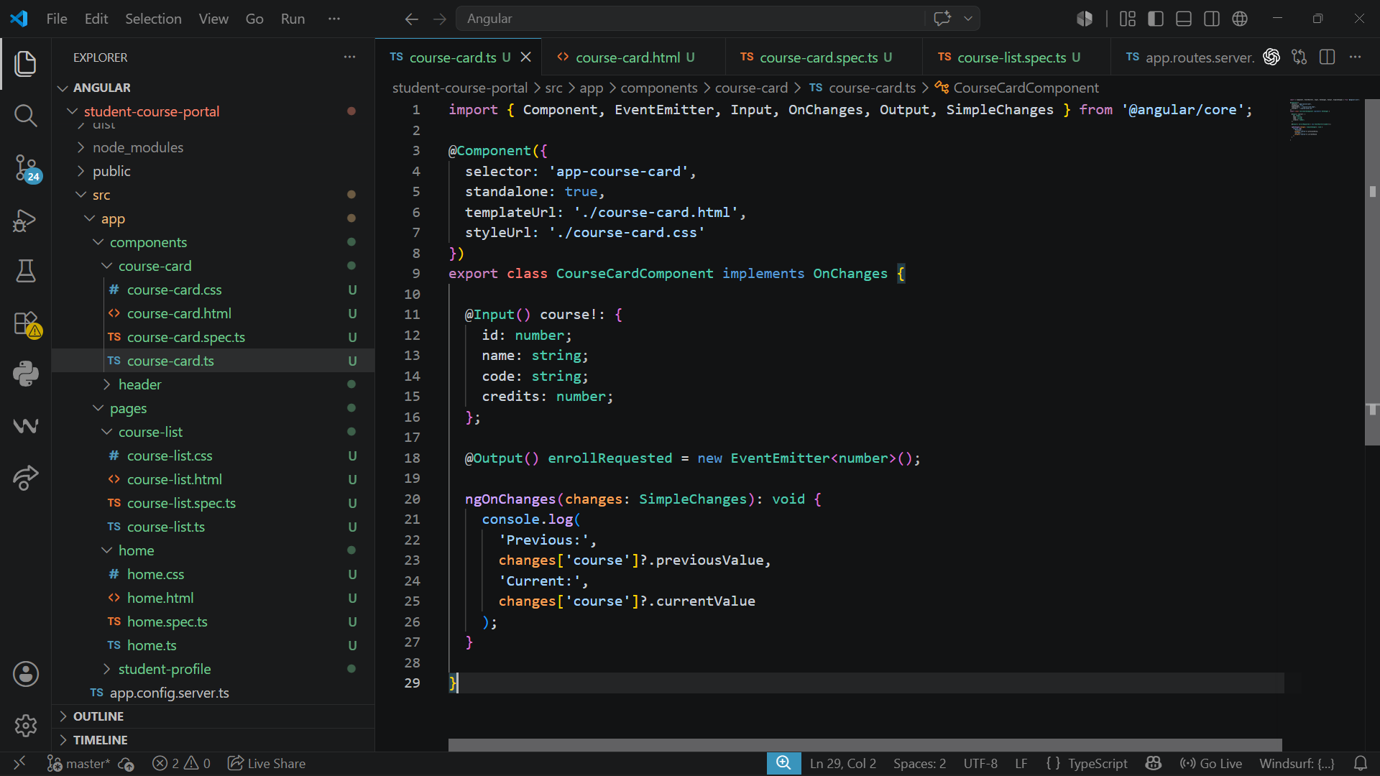

Course-list.ts
Defining a courses array
Implementing onEnroll
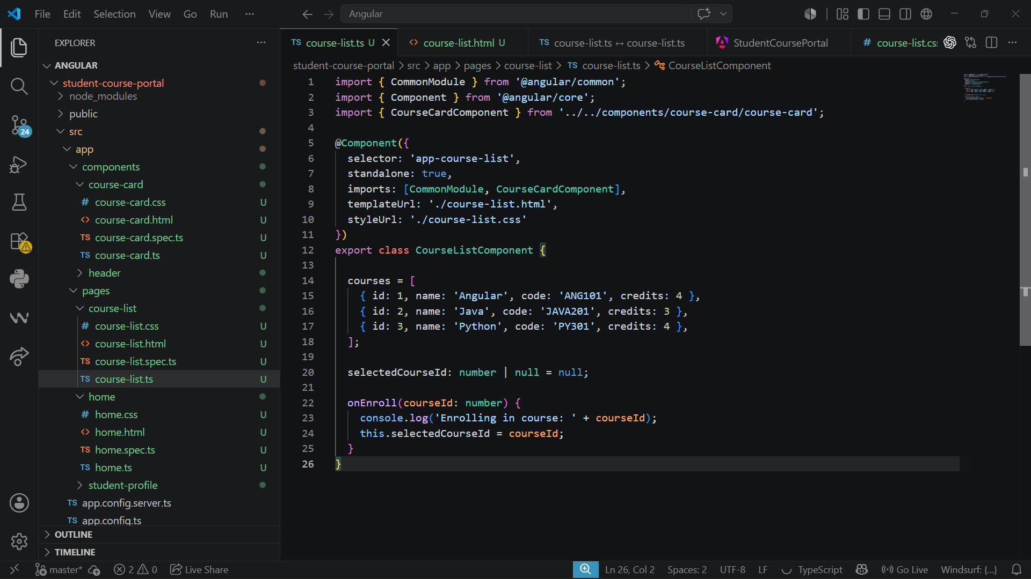
Course-list.html:
Display the selectedCourseId below the list:
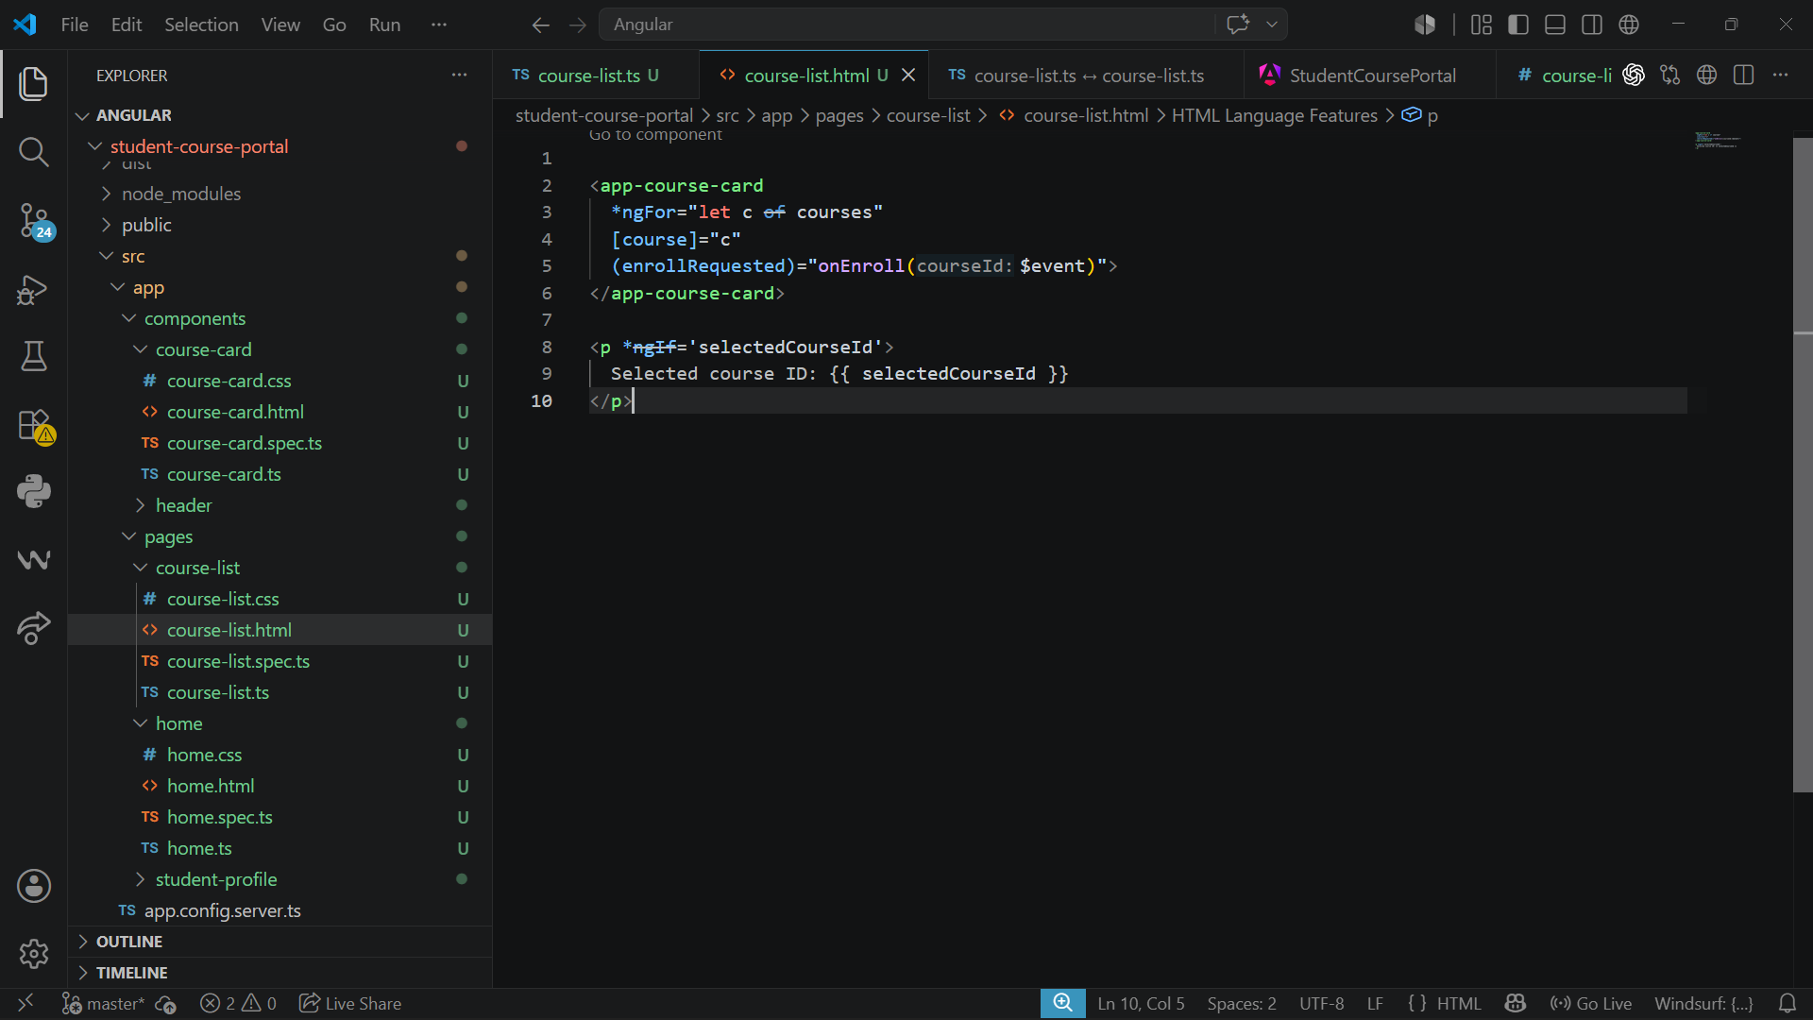
Output:
